Spring Boot JWT Authentication

Task Objective:
Build an authentication service using Spring Boot + Spring Security + JWT that:
- Accepts username/password via Basic Auth
- Returns a signed JWT token
- Protects other REST endpoints using the JWT token

📁 Project Setup
Project Name: spring-learn

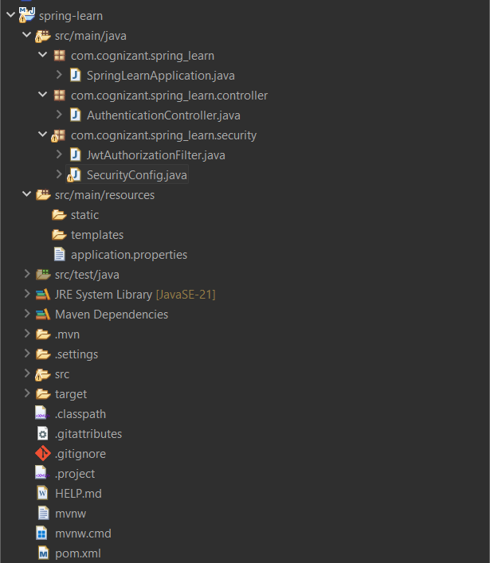

⚡ Dependencies in pom.xml
<dependencies>
<!-- Spring Boot Web -->
<dependency>
<groupId>org.springframework.boot</groupId>
<artifactId>spring-boot-starter-web</artifactId>
</dependency>

<!-- Spring Security -->
<dependency>
<groupId>org.springframework.boot</groupId>
<artifactId>spring-boot-starter-security</artifactId>
</dependency>

<!-- JWT -->
<dependency>
<groupId>io.jsonwebtoken</groupId>
<artifactId>jjwt</artifactId>
<version>0.9.0</version>
</dependency>

<!-- Fix for Java 11+ (JAXB) -->
<dependency>
<groupId>javax.xml.bind</groupId>
<artifactId>jaxb-api</artifactId>
<version>2.3.1</version>
</dependency>
</dependencies>

⚖️ Application Configuration
File: application.properties
server.port=8080

🚀 Spring Boot Entry Point
File: SpringLearnApplication.java
package com.cognizant.spring_learn;

import org.springframework.boot.SpringApplication;
import org.springframework.boot.autoconfigure.SpringBootApplication;

@SpringBootApplication
public class SpringLearnApplication {
public static void main(String[] args) {
SpringApplication.run(SpringLearnApplication.class, args);
}
}

🛡️ Security Configuration
File: SecurityConfig.java
package com.cognizant.spring_learn.security;

import org.springframework.context.annotation.Bean;
import org.springframework.context.annotation.Configuration;
import org.springframework.security.authentication.AuthenticationManager;
import org.springframework.security.config.annotation.authentication.builders.AuthenticationManagerBuilder;
import org.springframework.security.config.annotation.web.configuration.EnableWebSecurity;
import org.springframework.security.config.annotation.web.builders.HttpSecurity;
import org.springframework.security.crypto.bcrypt.BCryptPasswordEncoder;
import org.springframework.security.crypto.password.PasswordEncoder;
import org.springframework.security.web.SecurityFilterChain;

@Configuration
@EnableWebSecurity
public class SecurityConfig {

@Bean
public PasswordEncoder passwordEncoder() {
return new BCryptPasswordEncoder();
}

@Bean
public AuthenticationManager authManager(HttpSecurity http, PasswordEncoder encoder) throws Exception {
AuthenticationManagerBuilder auth = http.getSharedObject(AuthenticationManagerBuilder.class);
auth.inMemoryAuthentication()
.withUser("user").password(encoder.encode("pwd")).roles("USER")
.and()
.withUser("admin").password(encoder.encode("pwd")).roles("ADMIN");
return auth.build();
}

@Bean
public SecurityFilterChain filterChain(HttpSecurity http, AuthenticationManager authManager) throws Exception {
http.csrf().disable()
.authorizeHttpRequests()
.requestMatchers("/authenticate").permitAll()
.anyRequest().authenticated()
.and()
.authenticationManager(authManager)
.addFilter(new JwtAuthorizationFilter(authManager));

return http.build();
}
}

🔑 Authentication Controller
File: AuthenticationController.java
package com.cognizant.spring_learn.controller;

import io.jsonwebtoken.Jwts;
import io.jsonwebtoken.SignatureAlgorithm;
import io.jsonwebtoken.JwtBuilder;
import org.springframework.web.bind.annotation.*;

import java.util.Base64;
import java.util.Date;
import java.util.HashMap;
import java.util.Map;

@RestController
public class AuthenticationController {

@GetMapping("/authenticate")
public Map<String, String> authenticate(@RequestHeader("Authorization") String authHeader) {
String user = getUser(authHeader);
String token = generateJwt(user);

Map<String, String> map = new HashMap<>();
map.put("token", token);
return map;
}

private String getUser(String authHeader) {
String encoded = authHeader.substring(6);
byte[] decodedBytes = Base64.getDecoder().decode(encoded);
return new String(decodedBytes).split(":" )[0];
}

private String generateJwt(String user) {
JwtBuilder builder = Jwts.builder();
builder.setSubject(user);
builder.setIssuedAt(new Date());
builder.setExpiration(new Date(System.currentTimeMillis() + 20 * 60 * 1000));
builder.signWith(SignatureAlgorithm.HS256, "secretkey");
return builder.compact();
}
}

🔒 JWT Filter
File: JwtAuthorizationFilter.java
package com.cognizant.spring_learn.security;

import io.jsonwebtoken.*;
import jakarta.servlet.FilterChain;
import jakarta.servlet.ServletException;
import jakarta.servlet.http.HttpServletRequest;
import jakarta.servlet.http.HttpServletResponse;
import org.springframework.security.authentication.AuthenticationManager;
import org.springframework.security.authentication.UsernamePasswordAuthenticationToken;
import org.springframework.security.core.context.SecurityContextHolder;
import org.springframework.security.web.authentication.www.BasicAuthenticationFilter;

import java.io.IOException;
import java.util.ArrayList;

public class JwtAuthorizationFilter extends BasicAuthenticationFilter {

public JwtAuthorizationFilter(AuthenticationManager authManager) {
super(authManager);
}

@Override
protected void doFilterInternal(HttpServletRequest req, HttpServletResponse res, FilterChain chain)
throws IOException, ServletException {

String header = req.getHeader("Authorization");

if (header == null || !header.startsWith("Bearer ")) {
chain.doFilter(req, res);
return;
}

UsernamePasswordAuthenticationToken authentication = getAuthentication(req);
SecurityContextHolder.getContext().setAuthentication(authentication);
chain.doFilter(req, res);
}

private UsernamePasswordAuthenticationToken getAuthentication(HttpServletRequest request) {
String token = request.getHeader("Authorization");
if (token != null) {
try {
String user = Jwts.parser()
.setSigningKey("secretkey")
.parseClaimsJws(token.replace("Bearer ", ""))
.getBody()
.getSubject();

if (user != null) {
return new UsernamePasswordAuthenticationToken(user, null, new ArrayList<>());
}
} catch (Exception e) {
return null;
}
}
return null;
}
}

Console : 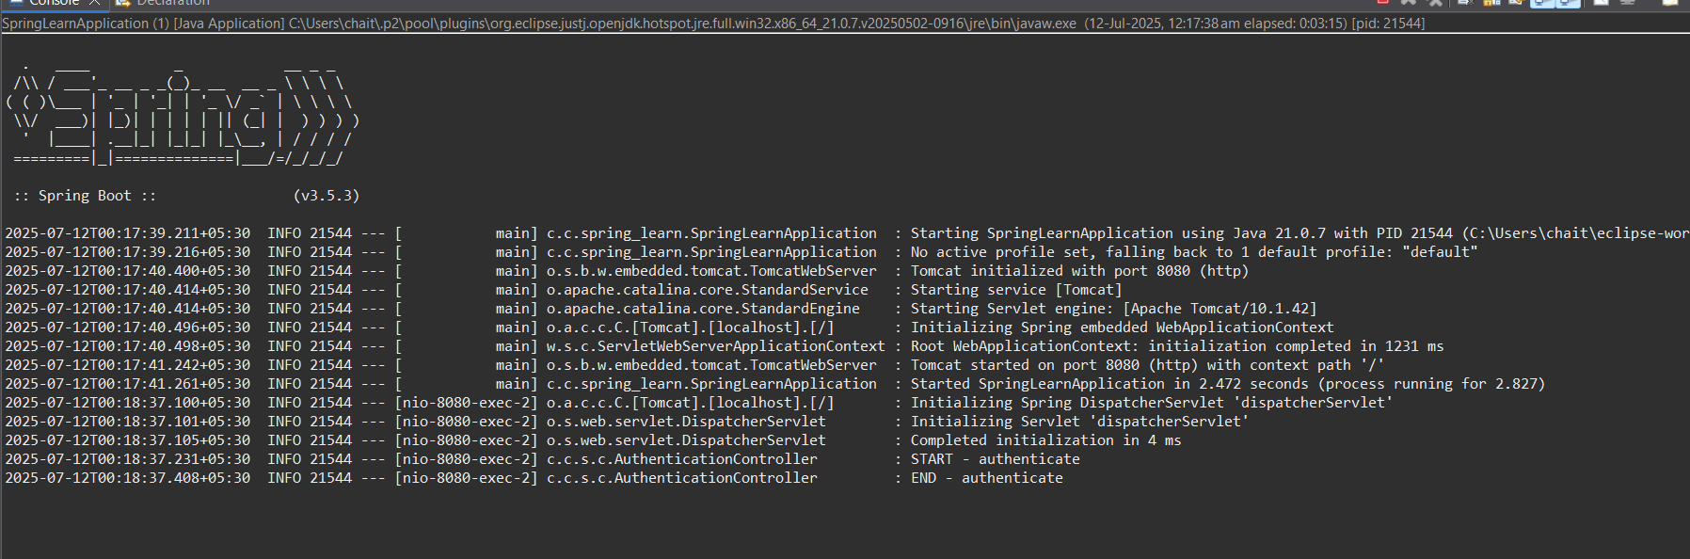

🔍 Testing /authenticate Endpoint (Postman)
- Method: GET
- URL: http://localhost:8080/authenticate
- Authorization: Basic Auth
  - Username: user
  - Password: pwd
